Beds AAA 10K Race Pack
Race Date
Friday 26th June 2026 Start time 7.30pm

Race Headquarters
Bedford International Stadium, Barkers Lane, Bedford. MK41 9SB
See below for area map.

Registration and Race Number collection

Runners must collect their RACE NUMBER on the day at the Race HQ. Please allow plenty of time to park, collect your race number and walk/jog to the start.
LIMITED RACE ENTRIES ON THE DAY £20.00 CLOSE 18:45

Minimum Age
All entrants must be at least 15 years old on the day of the race.

Car Parking
There is limited parking at the Stadium, and ample parking in the Aspects Leisure car park across the road. Entry to the Aspects car parks is next to McDonald’s. Please note: there is now a 2 hour maximum stay at this car park. See map below. Further parking is available close to the Start/Finish in Priory Park.

Changing, Toilets, Baggage
There are changing and toilet facilities for male and female runners at the Stadium. A baggage area is provided in the Race HQ but please do not leave any valuables. The race organisers will not take responsibility for any losses or damage incurred.

Race rules & etiquette
The race is run under UKA rules of competition, UKA License 30589. Please note that the wearing of headsets/headphones during the race is NOT PERMITTED for the safety of yourself and others. Runners who wear headsets will be disqualified. Run on the left hand side of the cycle way unless otherwise directed by the course marshals. Please be wary and courteous to other users of the cycle ways. E.g. Cyclists, dog walkers.

First Aid
First aid cover is provided by St John Ambulance. If you require medical assistance during the race, please inform a course marshal or another runner who will alert the first aid personnel. Two fully equipped St John Ambulance cyclists will be patrolling the course.

The Start
The start area is close to Priory Marina and is about 600 metres from the Stadium. Please allow 15 minutes to walk/jog to the start area. Take great care when crossing Barkers Lane.

The Course
Maps of the 10k race route will be on display in the Race HQ or you can view the route below. There is a water station just after 5km and water is also provided at the finish area.

The Finish
The race finish is close to the start line near Priory Marina. After crossing the finish line please stay in finish order in the funnel to enable accurate recording.

Timing

The event will be Gun to Chip timing, with finish line filming.

Winner’s trophies
1st 3 Men, 1st 3 Ladies, 1st MV40, MV45, MV50, MV55, MV60, MV65, MV70, 1st FV35, FV40, FV45, FV50, FV55, FV60, FV65, FV70. 1st Men’s Team (4 team), 1st Ladies’ Team (3 team).

Plus Beds County 10K Championship medal awards.

After the race
The presentation of trophies will take place in the Race HQ at approx. 8.45pm. Results will be emailed to runners and also available on the Beds AAA web site http://www.bedfordshireaaa.org.uk/ later.

Race HQ and parking
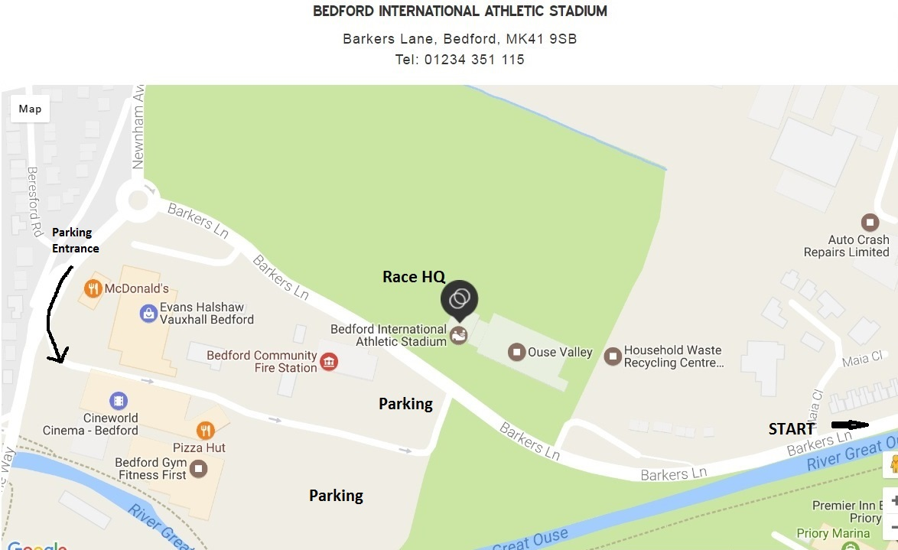

10k course map

